Experiment No : 1

Implement Linear and Logistic Regression on real-world datasets

1. Dataset Source
The dataset used for this experiment is a real-world Student Performance dataset.
Source Link: https://www.kaggle.com/datasets/ayeshasiddiqa123/student-perfirmance

2.Dataset Description
The Student Performance dataset contains information about students and their academic performance. The dataset includes features such as demographic details and study-related attributes (for example, gender, parental education, study time, etc.), along with the final score obtained by each student.
- Number of Instances: Depends on the dataset (e.g., ~1000 students)
- Features: Student-related attributes (numerical and categorical)
- Target Variable (Linear Regression):
  - Final_Score (continuous value)
- Target Variable (Logistic Regression):
  - Pass (binary class: 1 = Pass, 0 = Fail, derived from Final_Score using a threshold)
The dataset is suitable for demonstrating both regression and classification tasks using machine learning algorithms.

3. Mathematical Formulation of the Algorithms

Linear Regression:
Linear Regression models the relationship between the dependent variable yyy and independent variables x1,x2,...,xnx_1, x_2, ..., x_nx1​,x2​,...,xn​ as:
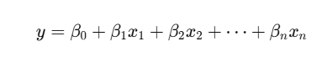
Where:
- yyy = predicted continuous output (Final Score)
- β0\beta_0β0​ = intercept
- β1,β2,…,βn\beta_1, \beta_2, \ldots, \beta_nβ1​,β2​,…,βn​ = model coefficients
The model parameters are learned by minimizing the Mean Squared Error (MSE).

Logistic Regression:
Logistic Regression is used for binary classification. It models the probability of class membership using the sigmoid function:
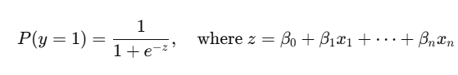
Where:
- Output is a probability between 0 and 1
- A threshold (e.g., 0.5) is used to classify the output into class 0 or 1 (Fail/Pass)
4. Algorithm Limitations

🔹 Linear Regression Limitations

- Assumes a linear relationship between input features and output.
- Sensitive to outliers, which can distort the regression line.
- Not suitable for complex non-linear patterns without feature transformation.

🔹 Logistic Regression Limitations
- Works best when classes are linearly separable.
- Performance degrades with highly non-linear decision boundaries.
- Sensitive to multicollinearity among input features.

5. Methodology / Workflow
The overall workflow of the experiment is as follows:

- Dataset Collection: Load the student performance dataset.
- Data Preprocessing:
  - Handle missing values.
  - Convert categorical features into numerical form using one-hot encoding.
- Feature Selection:
  - Select input features and define target variables.
- Train-Test Split:
  - Split the dataset into training and testing sets.
- Model Training:
  - Train Linear Regression for predicting final scores.
  - Train Logistic Regression for pass/fail classification.
- Model Evaluation:
  - Evaluate Linear Regression using MAE, MSE, RMSE, and R² score.
  - Evaluate Logistic Regression using Accuracy, Confusion Matrix, Precision, Recall, and F1-score.
- Hyperparameter Tuning:
  - Apply GridSearchCV to tune Logistic Regression parameters.
- Result Analysis:
  - Analyze model performance and interpret results.

6. Performance Analysis
- Linear Regression Performance:
The model performance is evaluated using regression metrics such as MAE, MSE, RMSE, and R² Score. A higher R² value indicates better predictive performance.
- Logistic Regression Performance:
The model performance is evaluated using Accuracy, Confusion Matrix, and Classification Report (Precision, Recall, F1-score). Higher accuracy and balanced precision-recall values indicate better classification performance.
The results show that both models are able to learn meaningful patterns from the dataset and provide reasonable predictions.

7. Hyperparameter Tuning
Hyperparameter tuning was performed for Logistic Regression using GridSearchCV. The regularization parameter CCC and solver were tuned to find the best combination that maximizes cross-validation accuracy.
This tuning process improved the classification performance by selecting the optimal model configuration, leading to better generalization on unseen test data.
Code:
# STEP 1: Import Required Libraries
import numpy as np
import pandas as pd
import matplotlib.pyplot as plt
import seaborn as sns

from sklearn.model_selection import train_test_split, GridSearchCV
from sklearn.linear_model import LinearRegression, LogisticRegression
from sklearn.metrics import (
mean_absolute_error, mean_squared_error, r2_score,
accuracy_score, confusion_matrix, classification_report
)
# STEP 2: Load Dataset
df = pd.read_csv("/content/student_performance.csv")
print("Dataset Preview:\n", df.head())
print("\nDataset Shape:", df.shape)

# STEP 3: Data Cleaning + Encoding
# Drop missing values
df = df.dropna()

# Convert categorical columns to numeric
df_encoded = pd.get_dummies(df, drop_first=True)

print("\nAfter Encoding Columns:\n", df_encoded.columns)

# PART A: LINEAR REGRESSION
# Target: Final_Score (Continuous)
X_lr = df_encoded.drop(columns=["Final_Score"])
y_lr = df_encoded["Final_Score"]

X_train_lr, X_test_lr, y_train_lr, y_test_lr = train_test_split(
X_lr, y_lr, test_size=0.2, random_state=42
)

lr = LinearRegression()
lr.fit(X_train_lr, y_train_lr)

y_pred_lr = lr.predict(X_test_lr)

print("\n===== LINEAR REGRESSION RESULTS =====")
print("MAE:", mean_absolute_error(y_test_lr, y_pred_lr))
print("MSE:", mean_squared_error(y_test_lr, y_pred_lr))
print("RMSE:", np.sqrt(mean_squared_error(y_test_lr, y_pred_lr)))
print("R2 Score:", r2_score(y_test_lr, y_pred_lr))

plt.figure(figsize=(6,4))
plt.scatter(y_test_lr, y_pred_lr)
plt.xlabel("Actual Final Score")
plt.ylabel("Predicted Final Score")
plt.title("Linear Regression: Actual vs Predicted")
plt.show()

# PART B: LOGISTIC REGRESSION
# Convert Final_Score → Pass / Fail
# Threshold = 65
df_encoded["Pass"] = df_encoded["Final_Score"].apply(lambda x: 1 if x >= 65 else 0)

print("\nPass/Fail Distribution:\n", df_encoded["Pass"].value_counts())

X_lg = df_encoded.drop(columns=["Final_Score", "Pass"])
y_lg = df_encoded["Pass"]

X_train_lg, X_test_lg, y_train_lg, y_test_lg = train_test_split(
X_lg, y_lg, test_size=0.2, random_state=42
)

log_reg = LogisticRegression(max_iter=1000)
log_reg.fit(X_train_lg, y_train_lg)

y_pred_log = log_reg.predict(X_test_lg)

print("\n===== LOGISTIC REGRESSION RESULTS =====")
print("Accuracy:", accuracy_score(y_test_lg, y_pred_log))
print("Confusion Matrix:\n", confusion_matrix(y_test_lg, y_pred_log))
print("Classification Report:\n", classification_report(y_test_lg, y_pred_log))

plt.figure(figsize=(5,4))
sns.heatmap(confusion_matrix(y_test_lg, y_pred_log), annot=True, fmt="d", cmap="Blues")
plt.xlabel("Predicted")
plt.ylabel("Actual")
plt.title("Confusion Matrix - Logistic Regression")
plt.show()

# PART C: HYPERPARAMETER TUNING
# Logistic Regression
param_grid = {
"C": [0.01, 0.1, 1, 10],
"solver": ["liblinear", "lbfgs"]
}

grid = GridSearchCV(
LogisticRegression(max_iter=1000),
param_grid,
cv=5
)

grid.fit(X_train_lg, y_train_lg)

print("\n===== HYPERPARAMETER TUNING =====")
print("Best Parameters:", grid.best_params_)
print("Best Cross-Validation Accuracy:", grid.best_score_)

Output:
Dataset Preview:
Hours_Studied Attendance Assignment_Score Midterm_Score Final_Score
0 1 60 55 50 52
1 2 65 58 55 57
2 3 70 60 58 60
3 4 75 65 62 64
4 5 80 68 65 68

Dataset Shape: (20, 5)

After Encoding Columns:
Index(['Hours_Studied', 'Attendance', 'Assignment_Score', 'Midterm_Score',
'Final_Score'],
dtype='object')

===== LINEAR REGRESSION RESULTS =====
MAE: 0.41749050153075906
MSE: 0.2612765457256682
RMSE: 0.5111521747245806
R2 Score: 0.9957516008825095

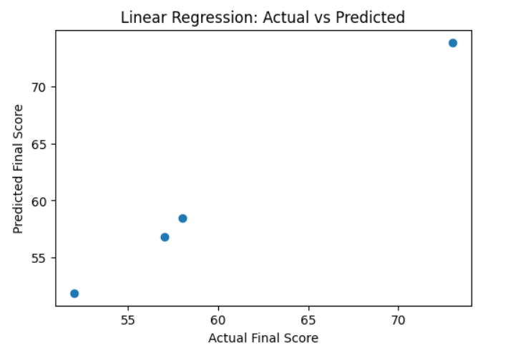

Pass/Fail Distribution:
Pass
1 13
0 7
Name: count, dtype: int64

===== LOGISTIC REGRESSION RESULTS =====
Accuracy: 1.0
Confusion Matrix:
[[3 0]
[0 1]]
Classification Report:
precision recall f1-score support

0 1.00 1.00 1.00 3
1 1.00 1.00 1.00 1

accuracy 1.00 4
macro avg 1.00 1.00 1.00 4
weighted avg 1.00 1.00 1.00 4

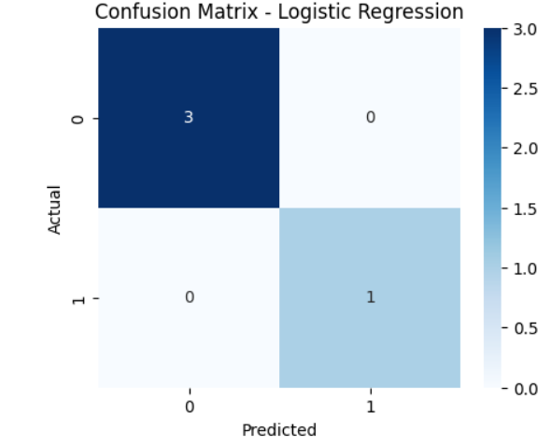

HYPERPARAMETER TUNING
Best Parameters: {'C': 0.1, 'solver': 'lbfgs'}
Best Cross-Validation Accuracy: 1.0

Conclusion
In this experiment, Linear Regression and Logistic Regression were successfully implemented on a real-world student performance dataset. Linear Regression was used to predict students’ final scores, while Logistic Regression was used to classify students into pass or fail categories. Proper data preprocessing, model evaluation, and hyperparameter tuning were performed. The experiment demonstrates how different machine learning algorithms can be applied to different types of prediction tasks using the same dataset.

